4th March 2014

YOKOHAMA to Release “BluEarth-A” Featuring Superior Wet Performance and Fuel Efficiency

Tokyo – The Yokohama Rubber Co., Ltd., announced today that it will launch a new edition to its fuel-efficient “BluEarth” tyre brand for passenger cars in Europe and Asia from this spring. Most sizes of the new “BluEarth-A” have been awarded the European tyre grading system’s C grade for rolling resistance and A for wet performance.
The “BluEarth-A” delivers the high degree of drivability and exceptional fuel efficiency that typifies YOKOHAMA pursuit of driving pleasure. In addition, it offers a well-balanced total performance featuring low noise, comfort and long-life. The application of a “nano BLEND compound” based on YOKOHAMA’s advance compound technology combined with an asymmetrical tread pattern provide “BluEarth-A” tyres with superior wet grip while enhancing their fuel efficiency and abrasion resistance. The asymmetrical tread pattern also contributes to the tyres’ exceptional rigidity and drainage characteristics. The “BluEarth-A” employs a “noise-controlled pitch” that contributes to a quieter ride by suppressing the incidence of uneven tyre wear. The tyre’s unique profile holds up well under the weight of large sedans and helps ensure a high level of control stability. YOKOHAMA has applied its proprietary aerodynamic technologies to reduce air drag and its dimple design on the tyre shoulders help to further raise the tyres’ fuel efficiency.
“BluEarth” is YOKOHAMA’s “environmentally, human and socially friendly” global tyre brand realizing not only excellent environmental performance, but reducing specific burdens on drivers, passengers and surrounding living environments – “friendly” performance. In addition to the “BluEarth-A,” other environmentally friendly products within the “BluEarth” range include the flagship “BluEarth-1” and the “BluEarth AE-01” which are already available on the market.
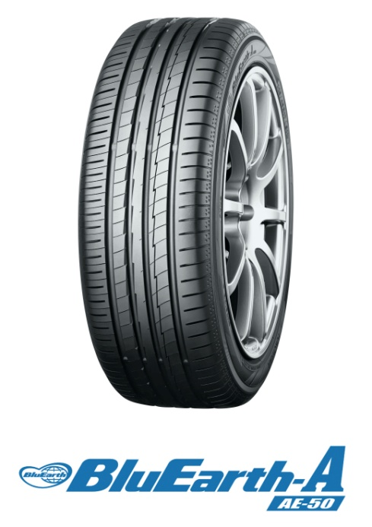

Release Reference Material

Secure Grip on Rainy Days

BluEarth-A special compound that elicits exceptional drivability
YOKOHAMA employs technologies and manufacturing methods in order to realize the best balance of fuel efficiency, wet grip and wear resistance.
The use of double silica and orange oil improves grip performance in the wet.
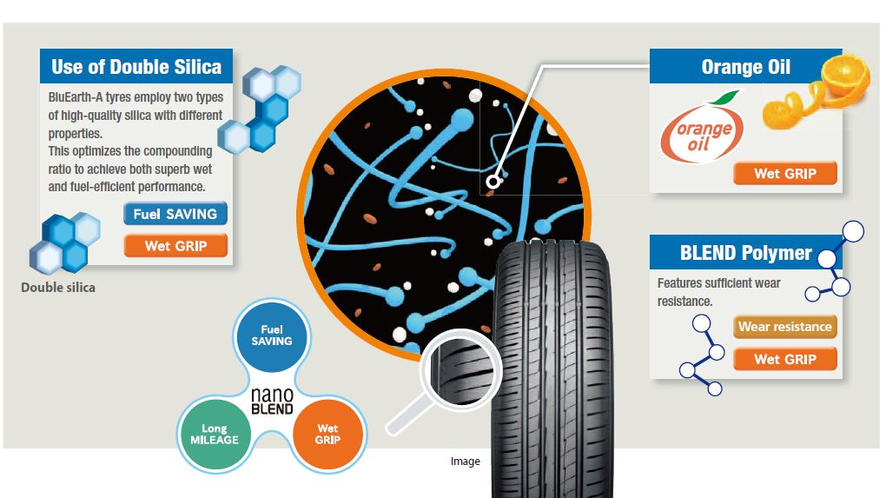

Lightning grooves provide a sense of reassurance on rainy days
Employs big and small lightning type grooves.
YOKOHAMA has expanded the groove volume while increasing block rigidity to enable safe and secure driving on rainy days.

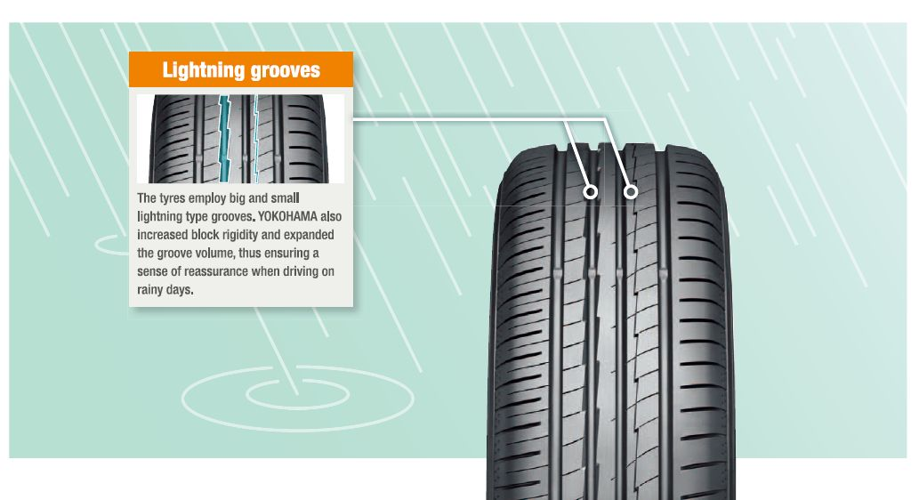

Low noise for a More Comfortable Ride
Innovative, new “noise-controlled pitch” ensures a consistently quiet ride
While continuing to ensure that noise is dispersed by varying the pitch, BluEarth-A tyrs suppress the incidence of uneven wear and maintain road noise as the tyres wear by making the pitch variation smaller.
New BluEarth-A tyres also boast an enhanced level of quietness by increasing the number of pitches to 84.
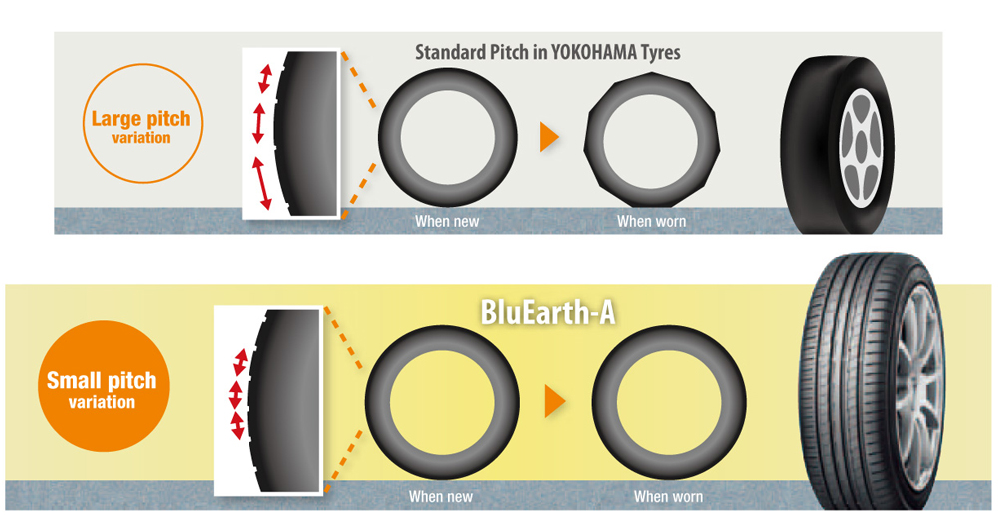

Total Balanced Performance

Profile achieving fuel efficiency and low noise
